Jessica Davila
Capstone Project
Oregon State University Fall 2011

Fisheries Kiosk

Ketchikan receives more than one million tourists a year. Visitors frequent the Southeast Alaska Discovery center. Ketchikan Misty Fords fisheries and wildlife partnership proposes to install an educational fisheries kiosk located at the discovery center in 2011. The interactive kiosk highlights district fish and wildlife opportunities and programs. Jessica Davila lead the project from beginning to installation at center.

- Request and receive funding for project through work plan
- Order kiosk and fill out
FSH 6300-4(3-80)
- Design pages(16) layout and gather images, writing and font for kiosk in HTML
- Install program onto kiosk
- Install security system on kiosk
- Install kiosk in Southeast Alaska Discovery Center
- Breakdown cost into a cheat sheet for future kiosk projects since this was the first on this district

III. Screen Shots of kiosk pages

VI. Picture of installed kiosk located in Ketchikan Discovery Center
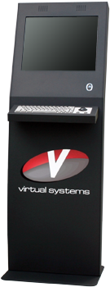

VII.
Item | Cost
Water logged designs  info@waterloggedin AK.com | $160.00/per page
Kiosk  Phoenix  1-877335-4675  Item # 1500401 | $3172.00- $2854.00  Ask for free shipping specials
20 days of someone’s time to gather/take images/ text/ design meet with designer order and install | Varied on grade level
Total project cost | For a 30 page, GS 5 about $9,980

