Grover Family Endowed Chair in Sustainable Urban Landscapes
January 1, 2025 - June 30, 2025, Report.

Alec Kowalewski, Ph. D, Professor
alec.kowalewski@oregonstate.edu
https://horticulture.oregonstate.edu/beaverlandscapes

The Grover Family Chair Endowment supports the Sustainable Landscape faculty position within the Department of Horticulture at Oregon State University. The turf position is a two-way (education and research), 9-month appointment, and reflects the land-grant mission of Oregon State University. The Grover Family Chair Endowment funds the summer portion of my salary, which is the time of year when most of my efforts are directed towards intern mentorship and research (Image 1).

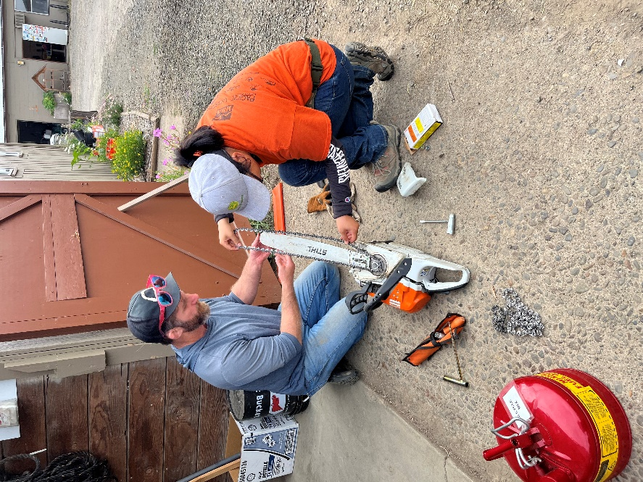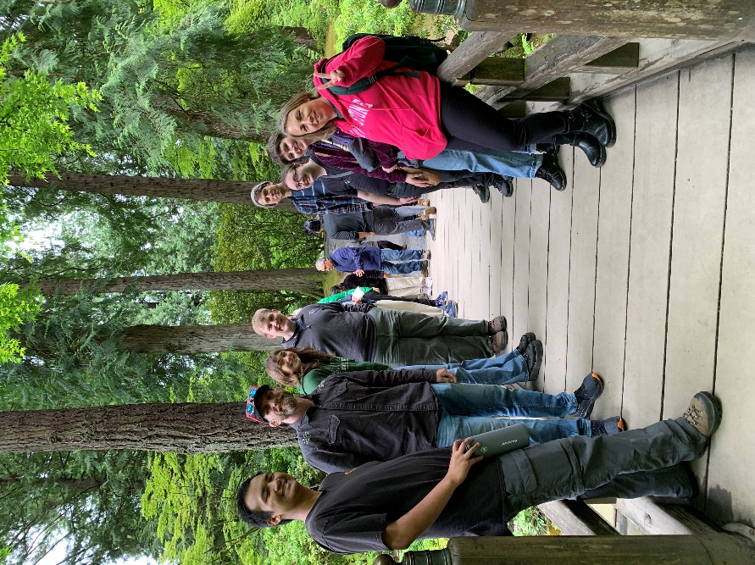

Image 1: Alec Kowalewski helping a student change a chainsaw blade at the Oak Creek Center for Urban Horticulture (left) and visiting the Portland Japanese Graden with the Landscape and Urban Horticulture Club.

Accomplishments Since January 2025
- Funding Generated: $490,373 total, $222,743 to my program.
- Undergraduate Courses taught: 5
- Publications: 7
- International Presentations: 6
- Current Graduate Assistants: 3
Current Graduate Assistants:

Iliak Harmsen-Saa, PhD Candidate

The objective of Iliak’s PhD dissertation is to evaluate barriers to adopting pollinator habitat in the urban landscape, identify pollinator plants that persist on the Oregon roadsides that receive periodic mowing and no other maintenance, and identify methods to convert irrigated turfgrass into non-irrigated pollinator habitat (Image 2). This research is being conducted at public schools across the state of Oregon, on roadsides in the Corvallis area, and at the OSU Lewis-Brown Horticulture Farm in Corvallis. Iliak’s research is funded by Western Sustainable Agriculture Research and Education (WSARE) and Project Apis m. Iliak is also serving as a 2025 Oak Creek Summer Intern Supervisor.

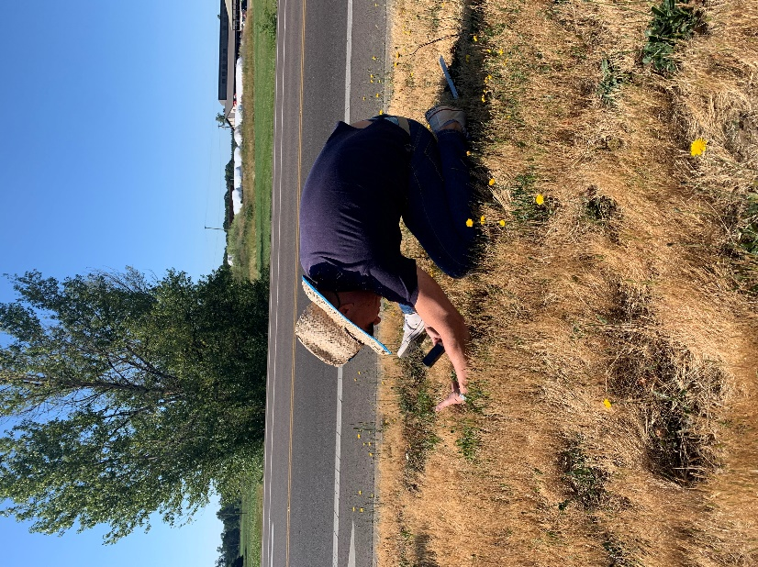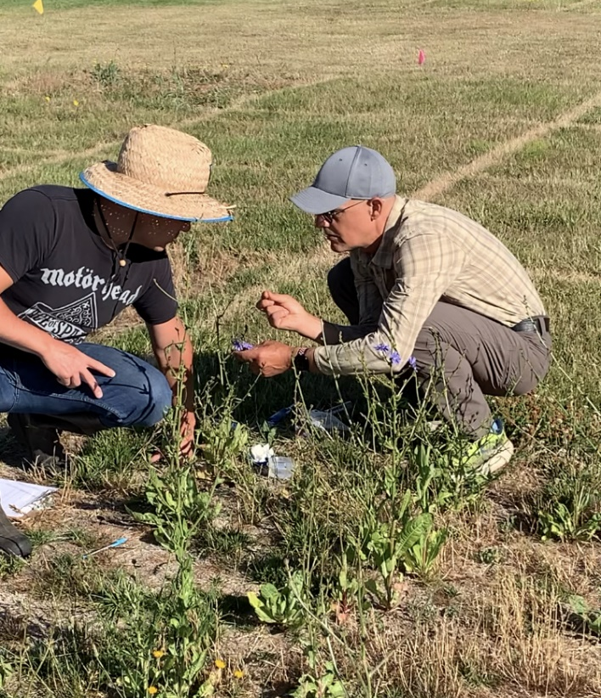

Image 2: Iliak Harmsen-Saa assess roadside pollinator plants in Corvallis, OR in the hopes of identifying potential species for future cultivation in home lawns (left), and evaluating the pollen quality produced by non-irrigated pollinator plants incorporated in preexisting lawns with the assistance of OSU Faculty, Andony Melathopoulos, PhD, at the Lewis-Brown Farm in Corvallis, OR.

Christian Sanchez, MS Candidate

The objective of Christian’s MS thesis is to identify commercially available landscape plants capable of being established with minimal irrigation in year one and maintained without irrigation in subsequent years (year 2 onward), and evaluating the ecosystem services of irrigated and non-irrigated tall fescue lawns (Image 3). Christian’s research is being conducted at the OSU Lewis-Brown Farm in Corvallis, OR. This research is supported by OSU Extension, the Hardy Plant Society of Oregon, and the Ontario Turfgrass Research Foundation. Findings were presented at the 2025 American Society of Horticultural Science meeting in New Orleans, Louisiana, and the 2025 International Turfgrass Research Conference in Japan. Christian is also serving as a 2025 Oak Creek Summer Intern Supervisor.

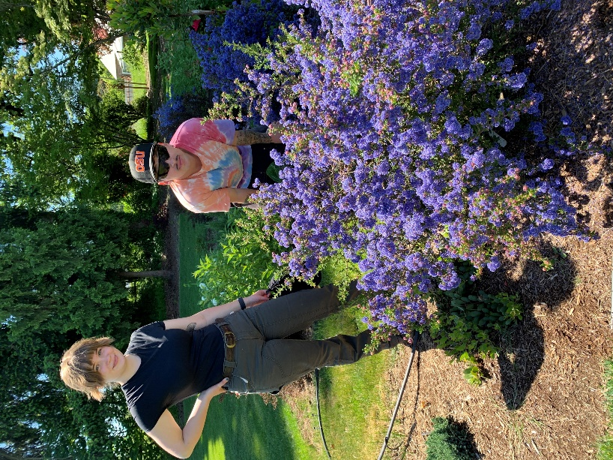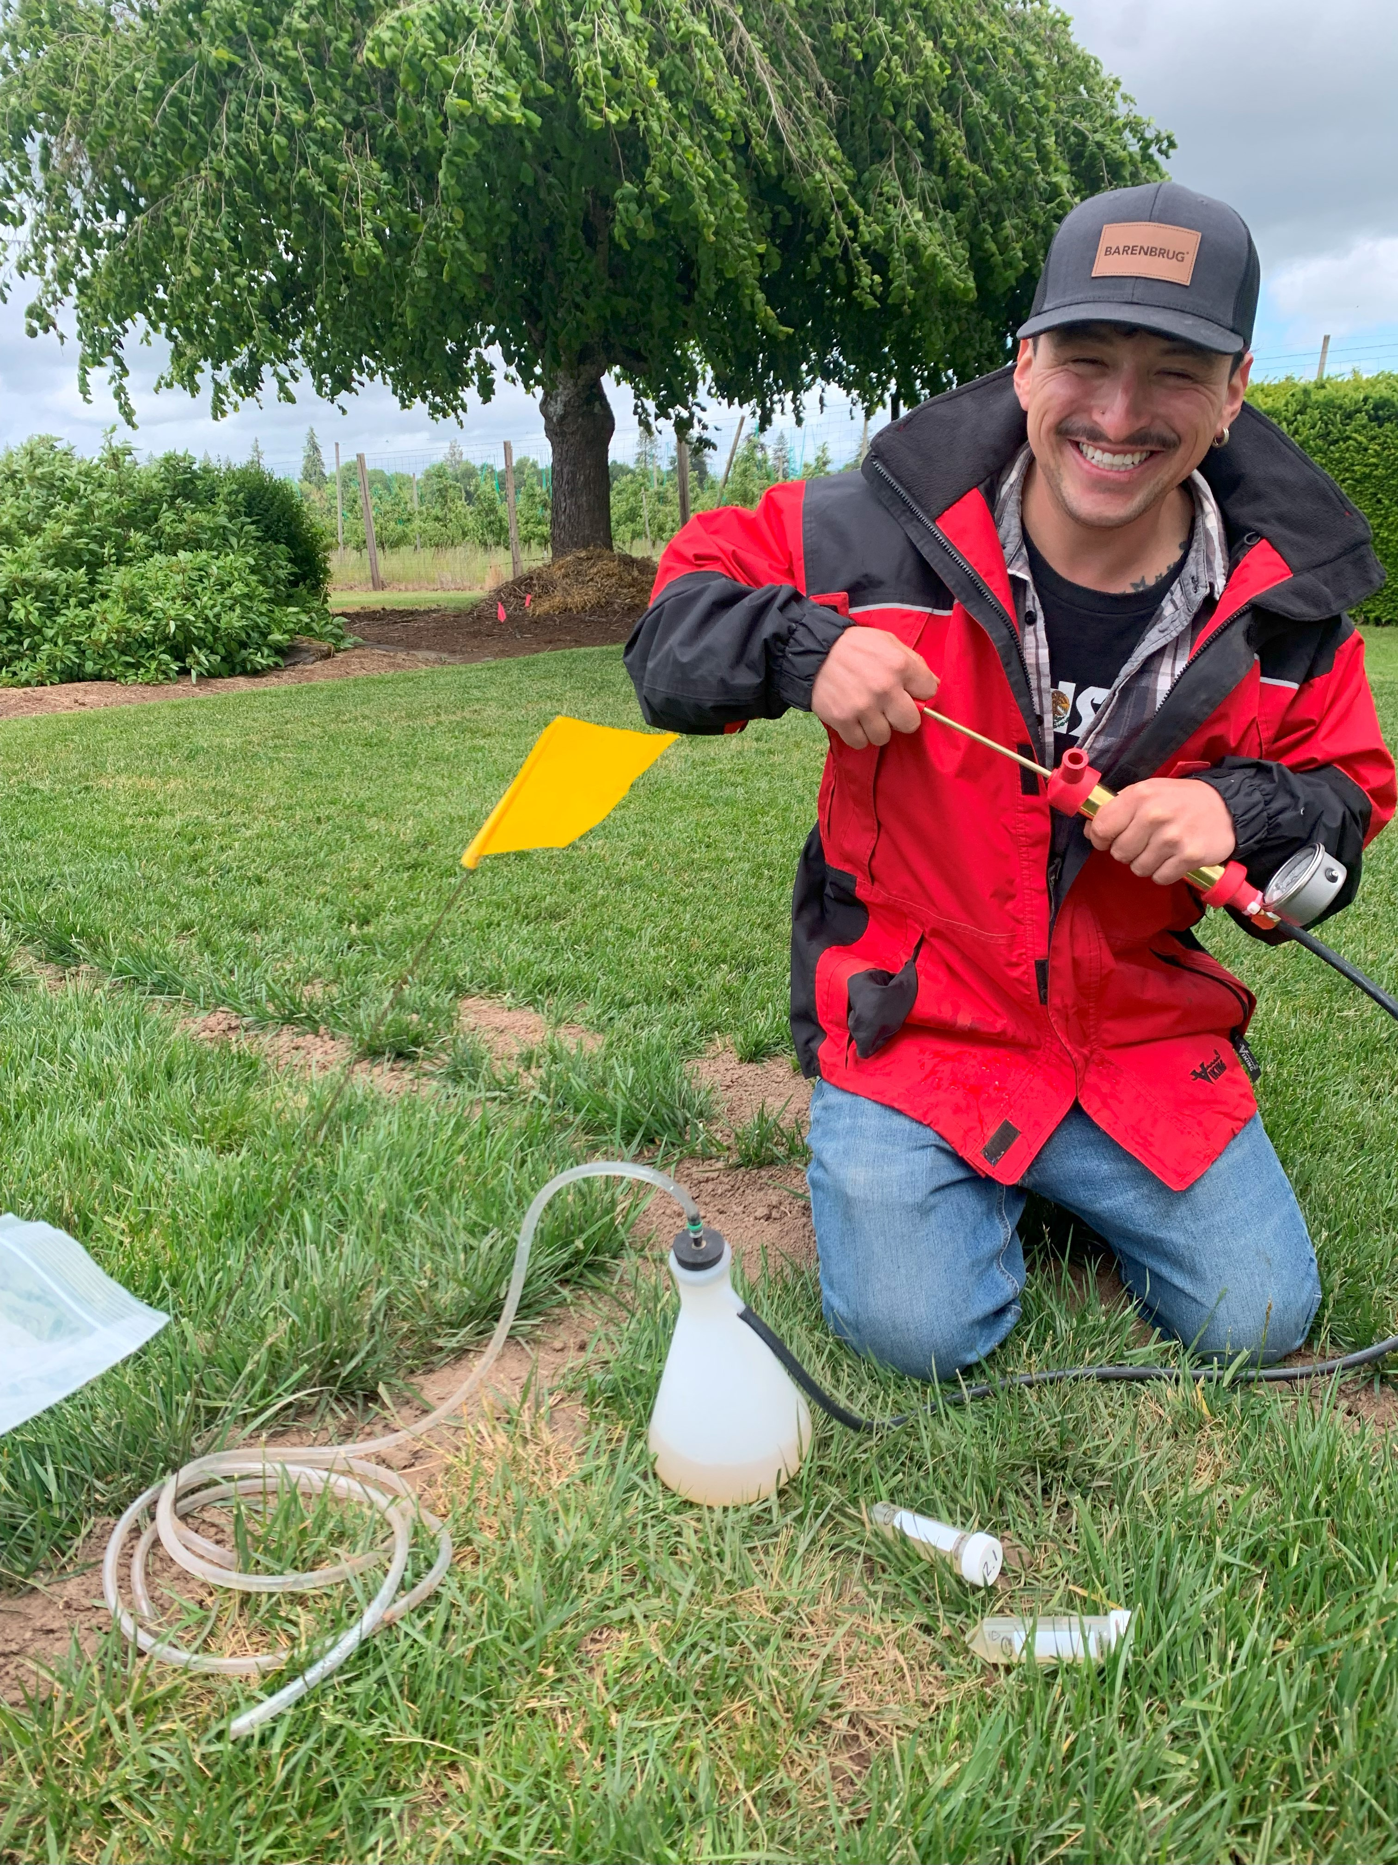

Image 3: Christian Sanchez assessing the drought tolerance and eco-system services of a recently established Ceanothus with assistance from undergraduate Lindsey Brooks (left) and the ecosystem service of irrigated vs non-irrigated lawns (right).

Emily Braithwaite, PhD Candidate
The objective of Emily’s PhD dissertation is to assess nematode populations in Oregon, Washington and California golf courses and grass seed fields. Specific emphasis will include distribution analysis of Anguina pacificae, a destructive turfgrass nematode identified in northern California which may have spread to adjacent states. Emily’s research is supported by the Golf Course Superintendents Association of America (GCSAA) and the Northwest Turf Association (NTA). Findings from this research were presented at the 2025 International Turfgrass Research Conference in Japan.
Student Mentorship:
Student mentorship has included a wide variety of activities including, but not limited to the following…

- 2025 Landscape and Urban Horticulture Club Advisor
- 2025 Oak Creek Center for Urban Horticulture Intern Advisor
- 2025 National Collegiate Landscape Competition in Fort Collins Colorado
- 2025 Ag and Natural Resource Day at OSU Main Campus
- 2025 Electric Landscape Equipment Exposition at Oregon State University
- 2025 Horticulture Club Portland Japanese Graden Field Trip
- 2025 Pacific Landscape Management Field Trip (Image 4)
- 2025 OSU Student Veterans Memorial Day BBQ at the Oak Creek Center (Image 4)

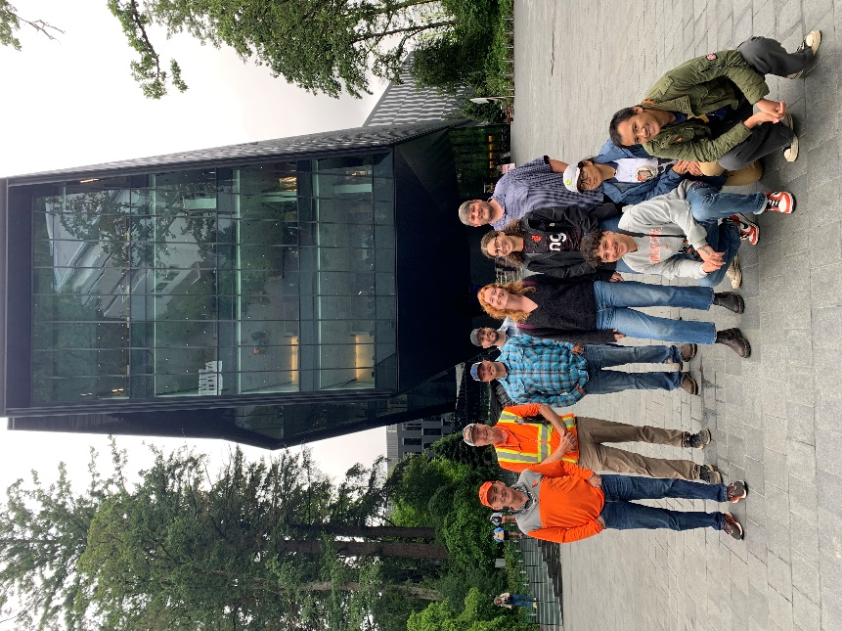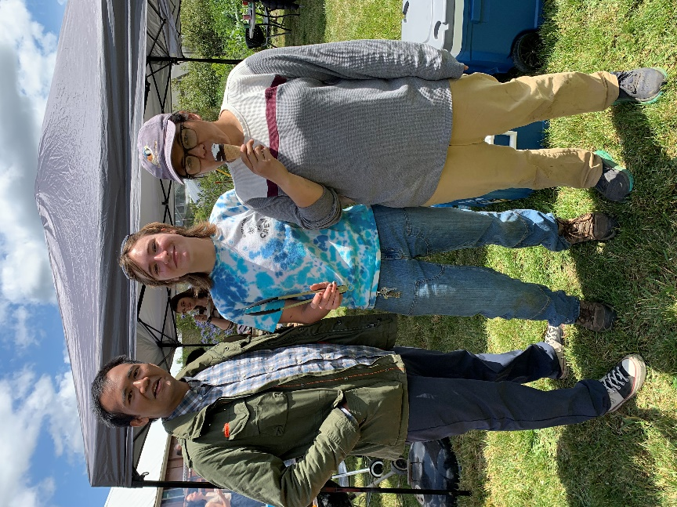

Image 4: Landscape and Urban Club visit Pacific Landscape Management (left) and host the first annual OSU Veterans Memorial Day BBQ at the Oak Creek Center for Urban Horticulture.

Upcoming Community Outreach Event
2025 Oak Creek Center Urban Horticulture Open House on September 5, 2025
- Where - 843 SW 35th St, Corvallis, OR 97331
- When and Who – September 5, 2025, from 11 am to 1 pm, lunch provided, all are welcome.
- RSVP – alec.kowalewski@oregonstate.edu by end of day August 29, 2025

